**Welcome to**

**Windsor Nursery School**

Acorn, Oak and Inclusion Plus Rooms

|  |  |  |
| --- | --- | --- |
|  |  |  |

***Our OFSTED REPORT (2019) states that***

* The school is at the heart of the community.
* Everyone works together to ensure that children thrive.
* Children love coming to school.
* The Nursery is a haven of calm.
* Adults have a strong understanding of how children learn and develop. They play and work alongside children and they watch what children do and intervene to move their learning forward.
* Children enjoy playing and exploring - This provides a strong foundation for future learning.
* Children grow into confident and independent learners.
* Right from the start, children learn to share and take turns. They make firm friendships.

**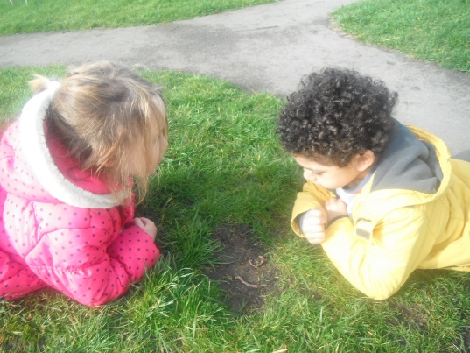Windsor Nursery School**

**Parkfield Road, Wolverhampton, WV4 6EL**

**Tel: 01902 558128** [**www.windsorcentre.com**](http://www.windsorcentre.com)

**MEET THE STAFF**

|  |  |  |  |
| --- | --- | --- | --- |
|  |  |  |  |
| **Babs**  Key Person | **Beth**  Key Person | **Chris**  Site team | **Clare**  Receptionist/ Clerical Assistant |
|  |  |  |  |
| **David M**  Head Teacher/ SENCO/DDSL | **David P**  Caretaker | **Jane**  Site team | **Kam**  Early Years Practitioner  Inclusion Plus (PT) |
|  |  | \\DMC-1007-01\users$\Desktops\jwatts\Desktop\STAFF PHOTO\Rachel_Taylor.JPG |  |
| **Kerry**  Early Years Practitioner  Inclusion Plus | **Paula**  Key Person | **Rachel**  Teacher Inclusion Plus DDSL | **Rebecca**  Admin and Finance co-ordinator |
|  |  |  |  |
| **Rena Patel**  Terrific for 2’s co-ordinator/ Designated Safeguarding Lead | **Sally**  Early Years Practitioner | **Sam**  Key Person | **Samantha**  Teacher Oak Class |
|  |  | T:\Staff\Admin\Becky\Staff photos\ID photos for badges\16_Susan_Jones.JPG |  |
| **Sophie**  Key Person | **Susan D**  Early Years Practitioner  SEND/IP | **Susan J**  Lunch time support  Inclusion Plus | **Tracey**  Early Years Practitioner  Inclusion Plus |

***The key principles which shape our ethos and pedagogy at***

***Windsor for our children and families are:-***

Ensuring that all children get to really know themselves and to appreciate they are competent, capable thinkers and learners who form effective relationships, feel secure , are supported to develop their ability to regulate their feelings, emotions and behaviour.

* We value parents as a child’s enduring educator
* We foster the development of children’s characteristics of learning—how children learn alongside what they are learning
* We recognise the importance of children having
  + effective communication and a broad vocabulary
  + secure attachments
  + good self-regulation as a development key to learning
  + spaciousness, time, quiet and attention in a rich natural environment

This then ensures that children are ready and able to access the rest of the curriculum on offer at Windsor.

***Our curriculum is based on the Early Years Foundation Stage***

***and we have 3 specific areas that we focus upon – Me, me and others and me, my world and my imagination***

|  |  |
| --- | --- |
| **A unique child** | Every child is a *competent learner from birth*, who can be *resilient, capable, confident* and *self-assured* |
| **Positive**  **Relationships** | Children learn to be *strong and independent* from a base of loving and *secure relationships* with parents and key person |
| **Enabling**  **Environments** | The environment *inside and outside* plays a crucial role in *supporting and extending* children’s development and learning |
| **Learning and**  **Developing** | Children develop and learn in *different ways* and at  *different rates* and all areas of learning are equally  important and interconnected |

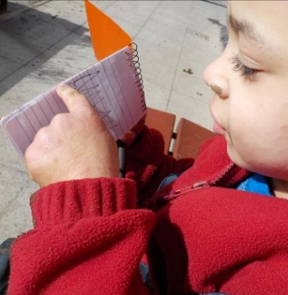

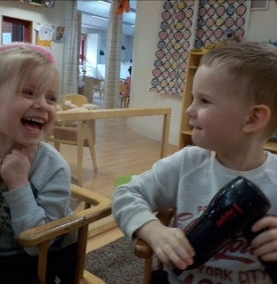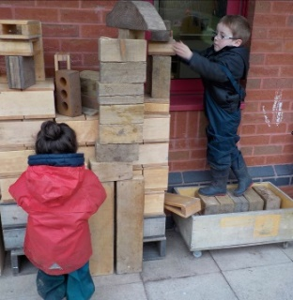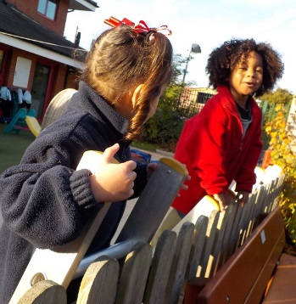

**Play underpins all development and learning for young children.**

**Play** is the basis from which each child’s learning begins.

Children need to be actively involved in play situations which give them opportunities to **explore, discover, imitate, pretend, talk, listen and solve problems with the companionship of other children** and of supportive adults who work alongside the children as knowledgeable companions, observe them, listen to them, support their learning and then at key moments challenge their thinking or teach specific skills to scaffold the children’s learning.

**Do you remember playing when you were a child?**

Think back...

What did you play with?

Where were you?

Who did you play with?

Who was in charge of it?

Do you remember what you learned through it?

Do you remember how you **felt** when you were playing what you wanted - with who you wanted to ?

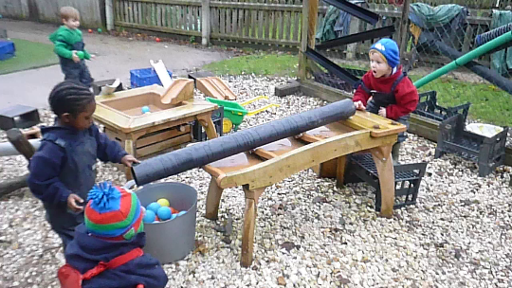

**Children haven’t changed—play is still the most important way that children learn**

Lots of research has shown why play that is chosen by the child is important

• Children use it to explore and make sense of the world,

• They use it to find out about their world and their relationship to it

• Play gives them a feeling of agency— ‘I want to, I know how and I can’. It makes them feel strong in tackling problems - an essential life skill we all need!

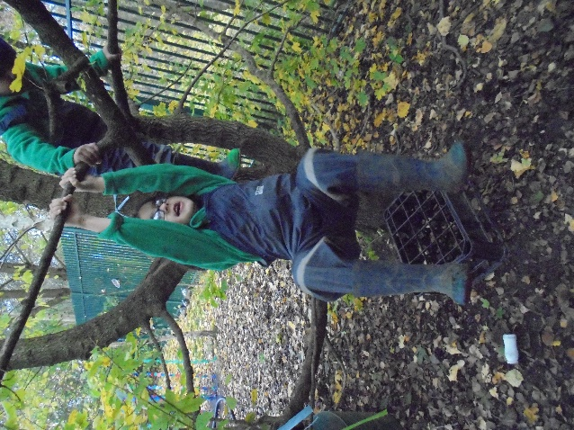

|  |
| --- |
| **It enables children to develop flexibility in thinking** |
| Playing about with things encourages children to try things out and be flexible.  They adapt to challenges they encounter, keep going and begin to solve their own problems |
| **It enables children to develop essential social and behavioural life skills** |
| Working alongside others in play is the most effective way to begin to understand about feelings—to be able to learn about sharing, taking turns and negotiating |
| **Through being in charge of their own play children feel *strong* and master self chosen challenges. It is deeply satisfying** |
| When children are in charge of the play they experience the feeling that ‘**I can do it’.** It feeds their *curiosity, confidence* and builds their *courage* |
| **When children are playing it reveals what children know and what they have learned** |
| It reveals their *competencies*—’You discover more about a person in one hour of play than in a year of conversation’—Plato |

**By supporting children in play we notice ..**

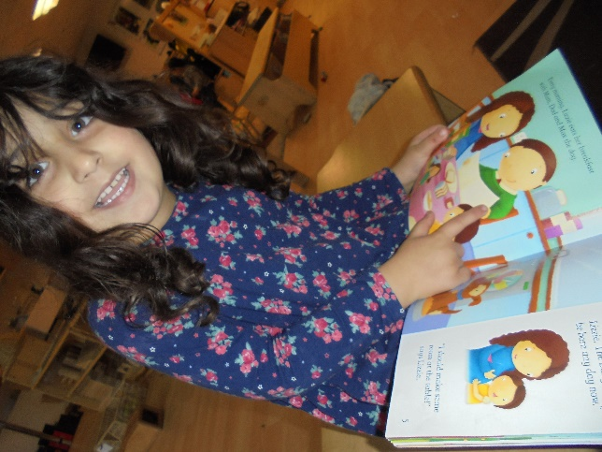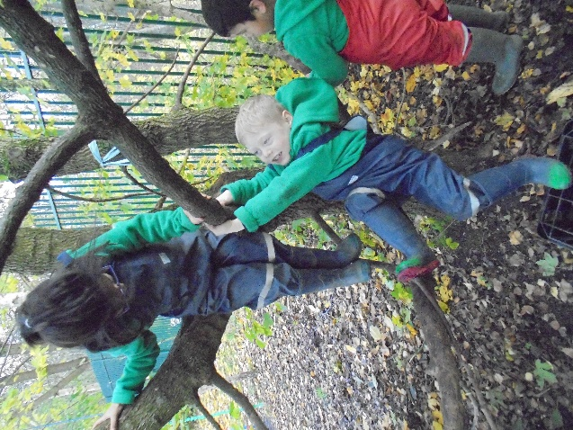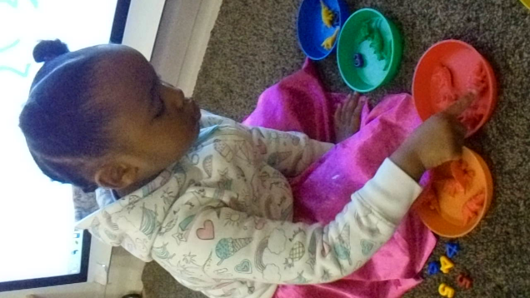

|  |
| --- |
| **PLAY enables children to become resilient, flexible and self-assured learners** |

**…So if play is so important to young children what do we do to ensure children have lots of opportunity to play?**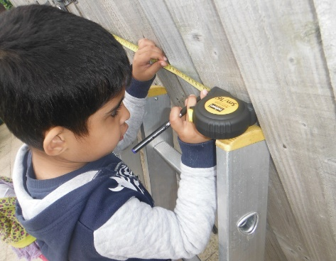

• Give them time to play and get involved in real learning adventures

• Give them freedom to play

• Give them space to play

• Join their play but don’t take over allow them to own their play

• Recognise it doesn’t need to have an immediate outcome the evidence develops in each unique child as they grow up

• Provide open ended resources—things that can be what the child wants them to be

• Support growing interests and fascinations and enrich language opportunities

**Then we see children flourish**

* they are mentally well
* they are physically well
* they communicate well
* they relate to each other well
* they confidently explore their world
* and in the face of challenge they keep on going and show real resilience

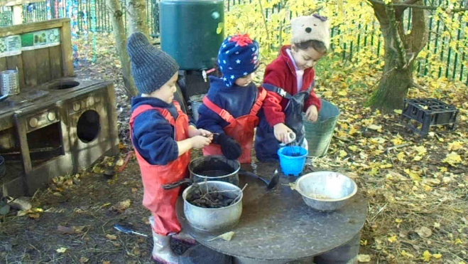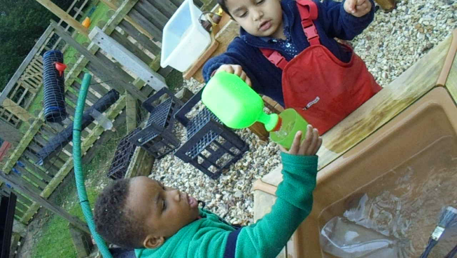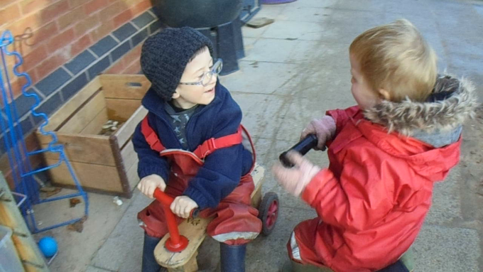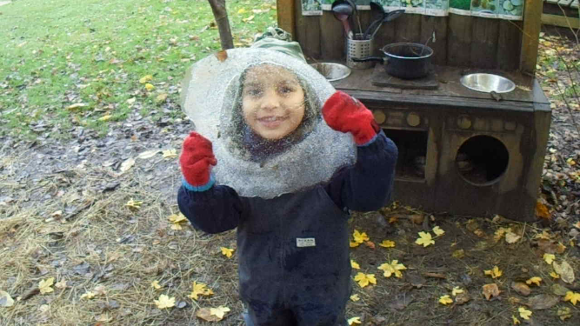

**What a session at Windsor looks like**

**Welcome time**

*Each key person welcomes their own children in their special way. This is a time to nurture and support, settle and set the tone for the day. Children self-register during this time. They then can work in their small family group with their key person on particular skills, or aspects of learning or engage in their own self chosen play.*

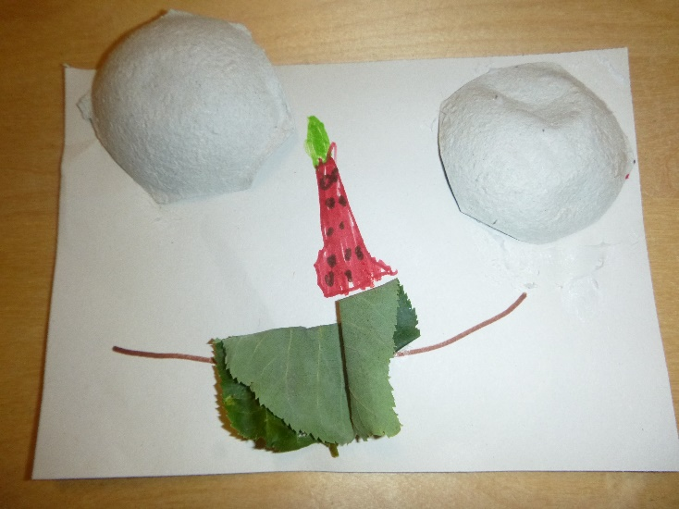

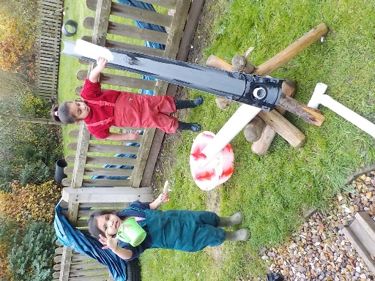**Area play - indoors and outdoors—***during this session staff are based indoors and out and children choose where they wish to play. At times we take the lead from the children’s fascinations and at other times we offer provocations, starting points, resources but most importantly we as staff revisit and reflect together on what has been developing to unpick children’s learning, development and deeper thinking. Staff work as researchers alongside the children, and act as expert’s within the areas of provision they support to children and other staff. There are additional opportunities available which include Forest Explorer sessions and bespoke focused group work to support social, communication and physical development when required. We have appropriate clothing for outdoors for the children and staff whatever the weather.*

**Family group time**

*In their family group the children share stories, play games and enjoy rhymes. This provides opportunity to share together with their friends and teacher. The children also have an opportunity to have a piece of fruit and some milk or water after a busy session.*

This provides a calm, joyful end to the session. Children can have a drink and choose a piece of fruit at this time.

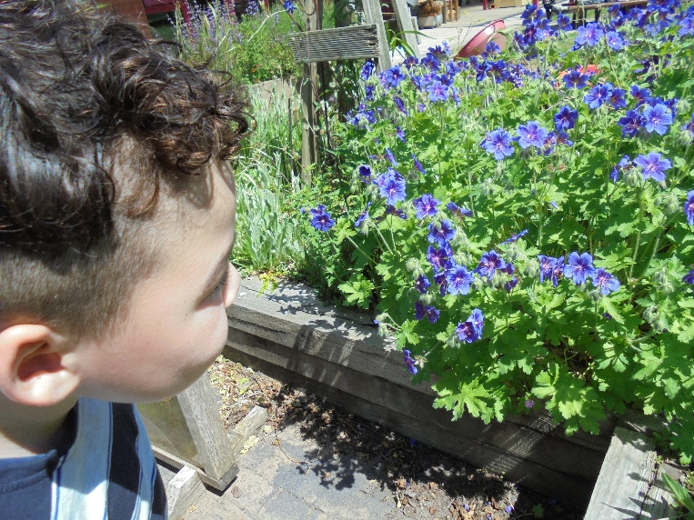

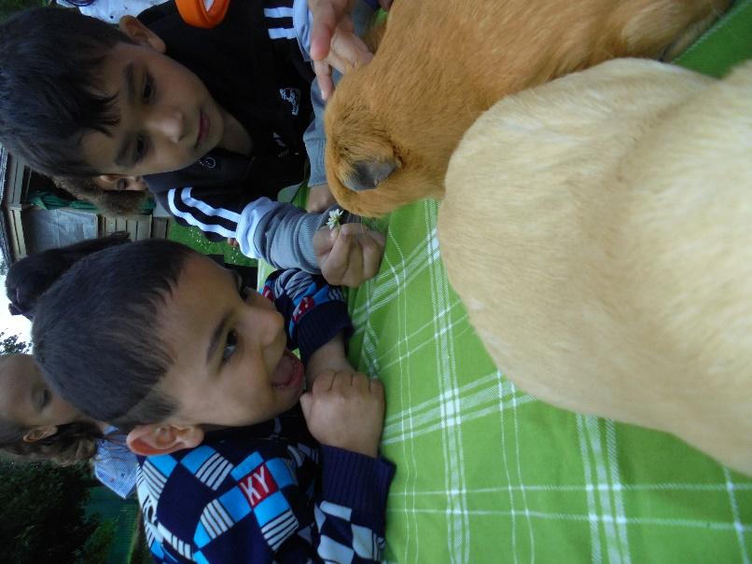

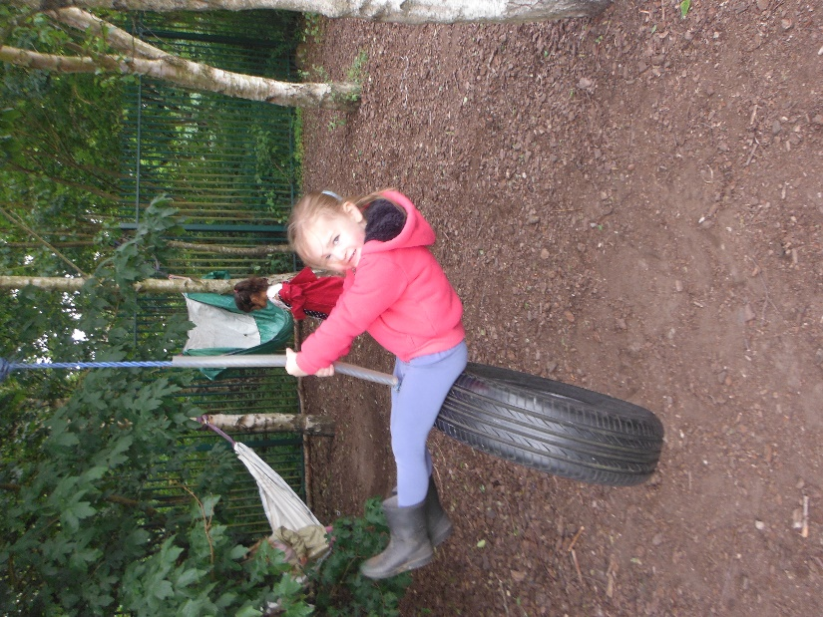

**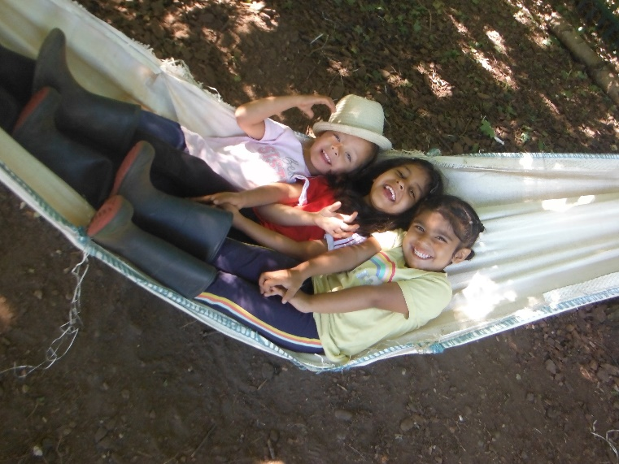**

**Inclusion Plus**

Children who are placed here by the Local Authority are part of our Inclusion Plus provision. The staff who work directly with the children have a high level of expertise and understanding of child development and are knowledgeable in the observation and assessment of the children and the use of strategies to support the development and learning of children with complex needs. The other richest resource is the other children to watch, learn from and play with.

**What is Inclusion Plus and what makes it different?**

The children within Inclusion plus all have an identified special educational need which impacts upon how they are developing and learning.

As with all children staff are available to talk with parents each session. In addition the children and families are supported by a **Team around the Child** termly meeting. Parents and professionals working with the child come together to discuss, ask questions and make sure the child is getting all the support needed. Goals are set for the child that ensure they are making good progress in their learning.

The children belong to a family group of children and have additional, bespoke support from experienced staff who understand their needs to make sure they are learning in the best way possible. This support looks different for every child and tailored to their interests, their developmental stage, their styles of learning and their specific needs.

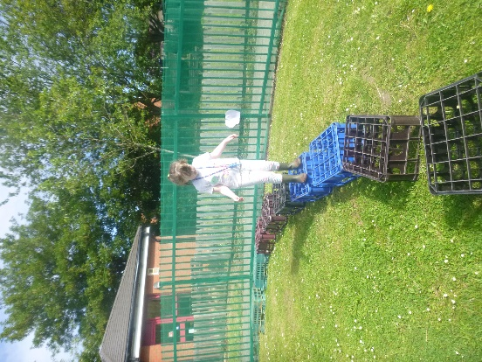 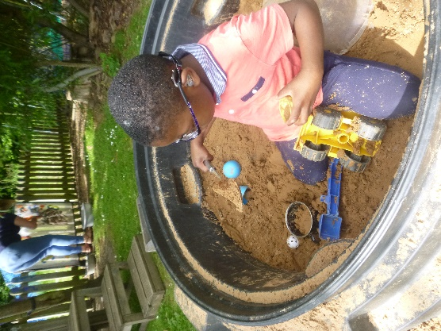 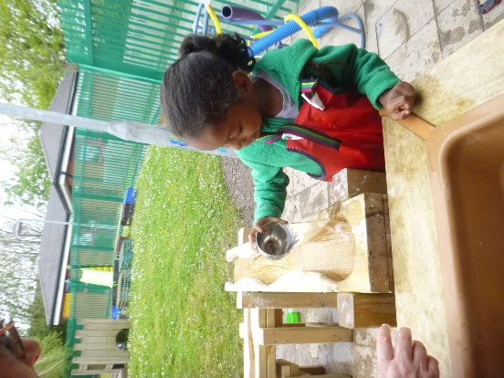

**Ensuring children make the very best progress**

Each child’s development is tracked and their progress monitored throughout their time at Windsor by the child’s key person through observation in play, small group time work and focused targeted work. Parents are regularly encouraged to share their own knowledge of their child and discuss their child’s progress.

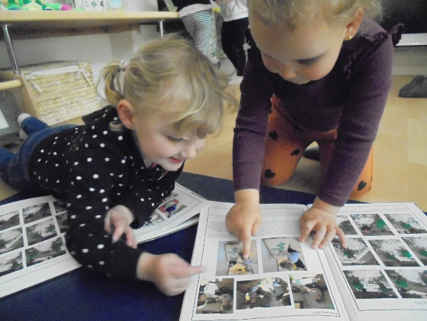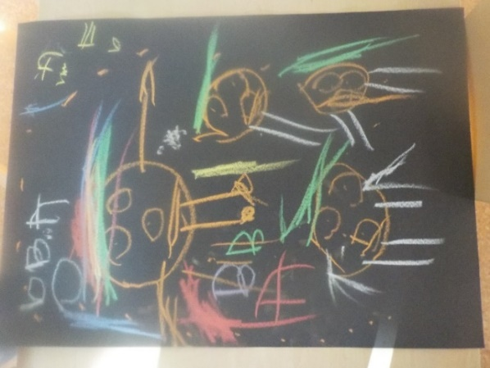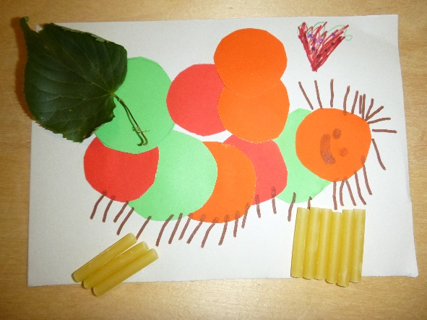Staff work closely together to share expertise and reflect on each child’s development and learning. Next steps in learning which are developed with parents are put in place during their time with us to ensure all children are making continued sustained progress.

|  |  |
| --- | --- |
|  |  |
|  |  |

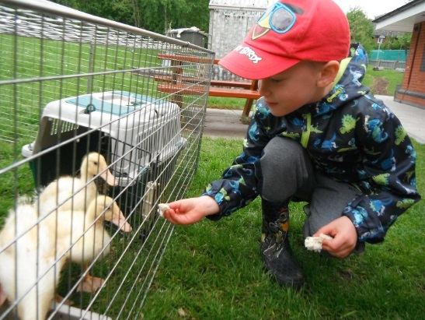

**Getting to know your child and your family**

**Establishing our relationship with our children and their families is very important to us.**

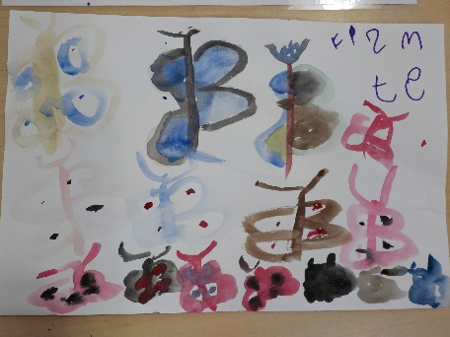Parents are the children’s first and most enduring educator and you already know lots about your child that will be of interest and help to us as we work with your child.

In order to begin these relationships you will be able to visit nursery in small groups. This will enable our staff to meet you and your child and collect useful information about your child.

Think about what they enjoy doing, who is special to them, what they like to do and where they like to play too. If there is anything else that is significant about your child that you would like to share with us too we would love to hear about it. We shall also check contact details and any other information necessary.

**If any contacts/phone numbers change, please ensure you inform your child’s teacher immediately. We must always be able to contact someone for your child should they become unwell or have an accident. If a child is not collected and we cannot contact anyone we have a duty to contact the Multiagency Safeguarding Hub.**

**Nursery Sessions**

**Your child can come to nursery for 15 hours each week.**

**They will be allocated a morning or an afternoon place. Session times will be agreed with you on your first visit. These will be within the following times**

**Morning Nursery 8.30 – 11.30 MAIN SESSION**

**Afternoon Nursery 12.15 – 3.15 MAIN SESSION**

**Your questions answered**

All of the team at Windsor are always happy to help you. Please tell us if you are worried or unsure about anything. Here are

answers to some of the questions parents often ask.

**How much does it cost?**

Nursery is free of charge. We ask for £1 a week nursery fund to help pay for extras, cooking items and resources.

**What if my child is ill?**

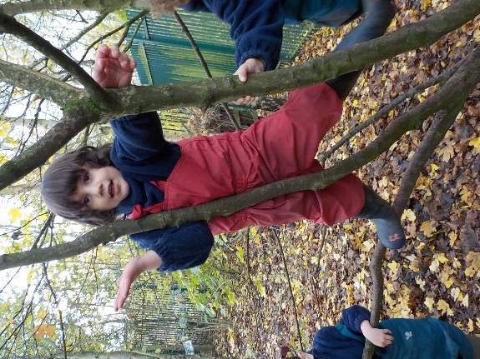Always telephone us to let us know if your child is not going to be at nursery. Children need to stay at home when they are unwell. They need to be clear of any tummy upset for at least 48 hours before they return to nursery.

If your child is taken ill at nursery we need to be able to call you or a relative to collect them. We must have numbers that are up to date and where there will always be someone to answer the call.

We have members of staff throughout nursery who are fully trained in First Aid. If your child hurts themselves at nursery we will tell you about it and ask you to sign our accident book.

**What if my child needs to take medicine?**

Most medication can be taken around nursery hours. The Medicine Policy for school states that in special circumstances prescribed medicine may be given to your child by a member of staff. Forms have to be completed and signed by you and member of staff, the medicine has to be labelled with the child’s name, date of birth, the name and strength of medication, the dosage and when the medication should be given and the expiry date before we can give medicine to your child. It will be stored securely.

**Can my child still come if they are in nappies?**

Children develop at different rates but usually children are toilet trained by the time they are three. If your child is finding this difficult we are happy to work with you to help them. It does not stop them taking up their nursery place.

**How do I know my child will be safe?**

All the team are well qualified and experienced in working with young children. Anyone who works at Windsor has had a disclosure and barring service check to say they are a safe person. All gates and doors are kept securely locked. Our designated child protection lead is Rena Patel or if absent David McCallin. Please take a look at our Safeguarding policy under the governance section of our website.

Only staff are allowed to let people in and out. All children have a password that their parent chooses in case someone else has to collect them in an emergency. This person **must** be over 14 years of age.

Fire drills and risk assessments are regularly carried out. Dogs are not allowed in the grounds or to be clipped to the fence. Smoking is not allowed on site. Please do not use mobile phones or cameras within the nursery.

**I am worried that my child will be upset**

Every child is different. Some children settle straight away and other children need a bit longer. We ask you to stay on site for a time within the first few visits while they are getting to know us. We want them to feel comfortable and it is worth spending the time they need at the beginning to give them a happy start. We will always contact you if your child needs you.

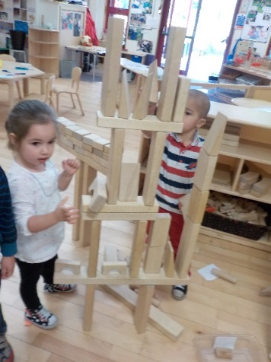Your child will be in a Family Group with other children in the nursery. They will have a special teacher to be a key person for them in the nursery.

**What if my child is not learning?**

If we are worried that your child is not learning as they should be we will always tell you straight away. Please tell us if you have any worries. We will then work together to make sure that help is at hand to support them. We work closely with other professionals like the speech therapy team and with your agreement we can ask them for specialist advice if required. Our Special Needs Coordinator is David McCallin. For further information visit our website and take a look at our local offer for SEND.

**What do they eat at nursery?**

Milk, water and fruit are available for the children each day. We support the children to eat healthily. Please tell us about anything your child should not eat. We always ask about allergies and cater for these.

**What should my child wear?**

Children need clothes that are easily washable as the best play is often the messiest – and we can guarantee your children will get messy! They also need clothing that is easy to take off and put back on themselves as developing their independence is very important at this stage in their development. Jogging bottoms, sweatshirts and T shirts are best. Velcro fasteners on shoes are essential. We provide suitable clothing for outdoor play – wellies, fleeces and waterproofs!

**What if my child isn’t behaving?**

Sometimes children are not used to being with lots of other children and having to share and take turns. We talk with the children and model kind behaviour so that they know what is acceptable. Young children are eager to please so we reinforce kind actions with praise.

When behaviour is unacceptable or they have hurt other children we would support them appropriate to their understanding and tell you about it. We always explain that it is the child’s **behaviour** - not the child that we do not like, and help them to understand what is acceptable.

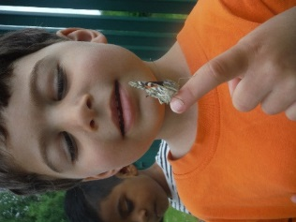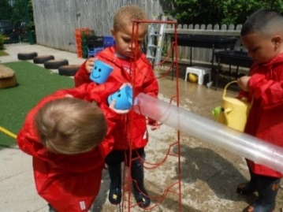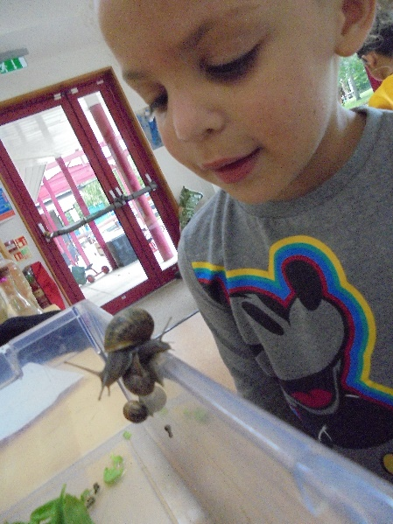

**Complaints Procedure**

Please let us know early on if you have a complaint to make.

Our policy is:

* Arrange to talk privately with the member of staff concerned.   
  If you are still unhappy ask to take the matter further
* Speak to the Head teacher who will try to see you on the same day. He will discuss the matter with you and the member of staff to try to sort out the issues
* If you are still not satisfied the Chair of Governors will be involved

A list of the Governors of Windsor Nursery School is available from the reception.

We teach our children to treat everyone with respect at all times and we expect everyone within our setting to do the same.

|  |  |
| --- | --- |
|  |  |
|  |

MCj04244660000[1]**Windsor winners**

We have some simple rules in nursery to make sure we take care of everyone and everything.

|  |  |
| --- | --- |
| DSCF7741 | **Always share**  **with everyone** |
| babyblackandwhitefeethandsphotographbighandssmallfeet-ae3bcb9f5dd5a88cde306865ca021603_h[1] | **Always have kind**  **hands and feet** |
| DSCF9562DSCF9562 | **Always use kind words** |
| chestnut%20shaker[1] | **Always help to tidy up** |